# Question 1

|  |  |  |  |
| --- | --- | --- | --- |
| **Research question** | **Univariate** | **Bivariate** | **Multivariate** |
| 1. Can source of funding be used to predict the successes or failure of a charity? | - Summary table of funding metrics (mean, median, SD, etc)  - Survived table  - Histogram income growth | - Correlation between public funding and income growth | - Logistic model, funding sources predicting survival  - Linear model, all funding sources predicting income growth |

## Univariate

The univariate analysis presents summary statistics for the variables which will be used in the analysis.

|  |  |  |
| --- | --- | --- |
|  | **Income 2011-2012** | **Income 2018** |
| **Count** | 10610 | 9458 |
| **Mean** | 1131168 | 1351087 |
| **Std** | 1291323 | 1655516 |
| **Median** | 675356 | 706700 |
| **Min** | 25004 | 0 |
| **Max** | 5925618 | 7400000 |

The income variables are used to the income growth variables below but are not used directly – they are highly skewed (their mean and median are very dissimilar and they have very high maximums compared to their means) and would need to be transformed for analysis.

|  |  |  |  |  |  |  |
| --- | --- | --- | --- | --- | --- | --- |
|  | **Absolute income growth** | **Ratio of income growth** | **Funding general public** | **Proportion funding general public** | **Funding** **government** | **Proportion funding government** |
| **Count** | 8578 | 10097 | 9997 | 10142 | 12150 | 12150 |
| **Mean** | 127746 | 1.074 | 11294 | 0.016 | 4714 | 0.001 |
| **Std** | 431806 | 0.477 | 24290 | 0.032 | 201745 | 0.023 |
| **Median** | 27081 | 1.101 | 0 | 0 | 0 | 0 |
| **Min** | -1015171 | 0 | -16896 | 0 | 0 | 0 |
| **Max** | 1529054 | 2.315 | 122848 | 0.151 | 19190000 | 0.902 |

N.B. The government funding variables have not been treated for outliers as it is small and highly skewed

Absolute income growth is also skewed with a very high maximum, but ratio of income growth is more suitable for analysis. This variable controls for the income charities started with; it is the income measured in 2018 divided by the income measured in 2011-2012. This variable also has the advantage of resulting in more interpretable regression output as it is more sensibly scaled than the other income measures.

Similar to ratio income growth, each measure of source of income is measured in both absolute and proportional terms. The absolute variables are extremely skewed and outlier heavy and they do not control for the size of a charity; i.e. a large charity may have a million pounds of government funding but this only represents a fraction of their total income while for a smaller charity half a million could be the majority of their funding. The proportional variables control for this by dividing the source of income by the total income for the organisation which produces a ratio. This ratio should be between 0 and 1 but, as shown in the maximum result for ‘proportion funding general public’ individual idiosyncrasies mean this can, in rare cases, exceed 1.

Proportion funding general public is displayed in the histogram below. It is a skewed variable with a leptokurtic kurtosis around its lower values. The implications of this visualisation are that most charities don’t gain the majority of their funding from the public. The public facing charities are the best known but many charities rely on endowments or other sources of funding.

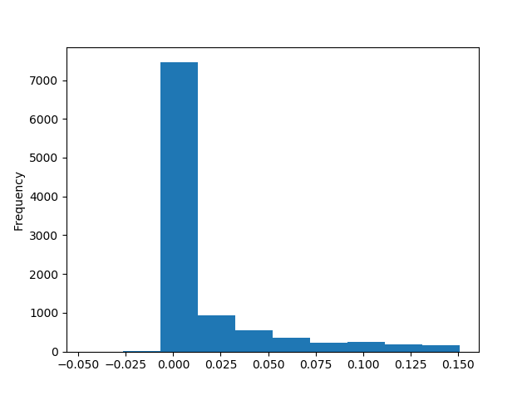

The small table below shows the distribution of the binary survival variable. Charities were classed as surviving if they were actively registered in 2017 (collected in 2018, the register data has a lag) after being sampled in the 2011-2012 data. This procedure did not account for changes of names. As shown the majority of the sampled survived, but there is enough variation to model survival based on this variable.

|  |  |  |
| --- | --- | --- |
|  | **Survived** | **Did not survive** |
| n | 10800 | 1350 |
| % | 88.9% | 11.1% |

## Bivariate

Bivariate testing was carried out using simple correlation as most of the variables are metric (aside from survival). Missing data was handled pairwise.

Correlation between **Funding general public** and **Absolute income growth**: 0.056

Correlation between **Proportion funding general public** and **Ratio of income growth**: 0.054

Correlation between **Funding government** and **Absolute income growth**: 0.011

Correlation between **Proportion funding government** and **Ratio of** **income growth**: 0.001

The first result shows a small positive correlation between general public funding and absolute income growth, however, which proportional and ratio versions of these variables are used the effect reduces and the direction inverts. This suggests a fragile relationship between these variables which is sensitive to controlling for total income. The government funding variable also changes in size when proportional variable are used – though it maintains its direction. These results to not measure how significant these relationships are, this is discussed below in the final modelling section.

## Multivariate modelling

|  |  |  |  |
| --- | --- | --- | --- |
| **Dependent**: Ratio income growth | **Coef.** | **Std error** | **P>|t|** |
| Proportion funding general public | 0.789 | 0.159 | 0.000 |
| Proportion funding government | -0.096 | 0.266 | 0.718 |
| Constant | 1.054 | 0.006 | 0.000 |

R-squared 0.003 Prob = 0.000 AIC =11450 BIC =11470

This first model is an OLS model which predicts income growth based on source of funding. Both of the effects in this model are insignificant, suggesting there is no evidence that source of funding affects subsequent income growth.

|  |  |  |  |
| --- | --- | --- | --- |
| **Dependent**: Survived | **Coef.** | **Std error** | **P>|t|** |
| Proportion funding general public | 3.897 | 1.099 | 0.004 |
| Proportion funding government | -2.206 | 0.942 | 0.020 |
| Constant | 2.005 | 0.035 | 0.000 |

R-squared 0.003 AIC =7155 BIC =7177

The second model is a logit predicting survival. In this model general public funding remains insignificant but government funding has a sizable and significant negative effect. The implications of this result is that charities who revive proportionally more of their funding from the government in 2011-2012 are less likely to survive to 2018. This may reflect the volatility of receiving high proportions of funding from government programs which tend to be for a set period, or can be terminated as the party in power changes.